**LAB 05 - PS**

01)

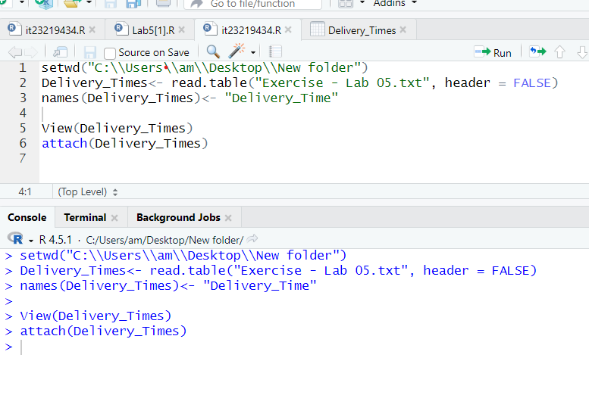

02)

03)

04)

